Coexistence between RMR in the 900 MHz range and other applications in adjacent bands

approved DD Month YYYY

ECC Report 313

# Executive summary

The present ECC Report studies the compatibility of Railway Mobile Radio (RMR) in the 900 MHz range with adjacent applications as part of the answer to the mandate from the European Commission on FRMCS.

The studies show that the 900 MHz frequency range is feasible for RMR systems, under the condition that the RMR cab-radio fulfils some blocking requirements more stringent than those currently specified by 3GPP for band #8.

**Requirements on RMR BS:**

Table 1: Requirements on GSM-R and FRMCS BS receiver characteristics

|  |  |
| --- | --- |
| Parameter | Value |
| Level of the wanted signal | Sens + 3 dB |
| Maximum interfering signal in  870-874.4 MHz (Note 2) | -24 dBm |
| Note 1: The antenna connector of the radio module is the reference point.  Note 2: These requirements cover both blocking and third-order intermodulation. It is up to ETSI to define a relevant interfering signal against which the conformity test will be performed. In this Report, the interfering signal considered is 200 kHz wide. | |

**Requirements on GSM-R cab-radio:**

Table 2: Additional requirements on GSM-R cab-radio receiver characteristics

|  |  |
| --- | --- |
| Parameter | Value |
| Level of the wanted signal | Sens + 3 dB |
| Maximum interfering signal in  916.1-918.9 MHz (Note 2) | -26 dBm |
| Note 1: The antenna connector of the radio module is the reference point.  Note 2: These requirements cover both blocking and third-order intermodulation. It is up to ETSI to define a relevant interfering signal against which the conformity test will be performed. In this Report, the RFID interfering signal considered is 400 kHz wide. | |

Improved GSM-R cab-radios as per ETSI TS 102 933-1 [7] are currently under deployment and do not fulfil the requirement above. Considering this and the specific equipment life cycle in the railway environment, alternative mitigation techniques, such as to coordinate RFID interrogators at a national level. Hence, the additional requirement in the table above can be made optional in the ETSI specification only for the GSM-R cab-radio.

These SRD and RFID results are based on theoretical calculations and not in a test environment, therefore testing of scenarios may be required to refine the assumptions and results.

**GSM-R carrier at 919.6 MHz:**

In some worst-case scenarios, the GSM-R cab-radio receiving at 919.6 MHz may face interference from 25 mW SRD due to blocking.

**Requirements on FRMCS cab-radio:**

Table 3: Requirements on FRMCS cab-radio receiver characteristics

|  |  |
| --- | --- |
| Parameter | Value |
| Level of the wanted signal | Sens + 3 dB |
| Maximum interfering signal in  880-918.9 MHz (Note 3) | -26 dBm |
| Maximum CW interfering signal in  925.6-927 MHz | -13 dBm |
| Maximum CW interfering signal  in 927-960 MHz | -10 dBm |
| Maximum 5 MHz LTE interfering signal  (lowest carrier at 927.6 MHz) | -13 dBm |
| Note 1: The antenna connector of the radio module is the reference point.  Note 2: These requirements cover both blocking and third-order intermodulation.  Note 3: It is up to ETSI to define a relevant interfering signal against which the conformity test will be performed. In this Report, the RFID interfering signal considered is 400 kHz wide. | |

It is considered that a spurious emission limit of -36 dBm/100 kHz from an RFID interrogator should be sufficient to ensure coexistence between RFID interrogators and RMR cab-radios in all cases, including those in private sitings.

The highest RFID interrogator channel is centred at 918.7 MHz, operating in 918.5-918.9 MHz. For FRMCS, the lowest possible RB starts around 919.6 MHz. The spurious level of -36 dBm/100 kHz is fulfilled from 919.7 MHz upwards.

No additional requirement is necessary on unwanted emissions from other SRD.

**MFCN out-of-band emissions:**

[The studies show that in some worst cases, if mitigation techniques are not adopted, out-of-band emission of MFCN BS may exceed the protection criteria of the FRMCS cab-radio.]

1. The section 4.1.4 is expected to be reviewed and revised during the public consultation.

TABLE OF CONTENTS

0 Executive summary 2

1 Introduction 8

2 Frequency use 9

3 RMR technical parameters 10

4 Coexistence between RMR cab-radio and MFCN in the 900 MHz range 12

4.1 Coexistence between RMR cab-radio and MFCN BS above 925 MHz 12

4.1.1 Blocking and intermodulation 12

4.1.2 Considerations on RMR minimum signal level and radio planning level 12

4.1.2.1 Derivation of the ACS value 12

4.1.2.2 Minimum wanted signal level at cab radio antenna connector 13

4.1.2.3 Corresponding level for radio planning 13

4.1.3 Impact of MFCN unwanted emissions on FRMCS cab-radio 15

4.1.3.1 Assumptions on parameters 15

4.1.3.2 Antenna gain of the MFCN base station in the direction of the cab-radio 17

4.1.3.3 Propagation path loss 18

4.1.3.4 Interference calculation 20

4.1.3.5 Duration of the interference 20

4.1.3.6 Results 21

4.1.3.7 Conclusions 21

4.1.4 MFCN out-of-band emissions at RMR cab-radio max blocking signal level 23

4.2 Coexistence between RMR cab-radio and MFCN aerial UE below 915 MHz 23

5 Coexistence between RMR cab-radio and SRD below 919.4 MHz 25

5.1 500 mW SRD 25

5.1.1 500 mW SRD NAP above rooftop 25

5.1.2 500 mW NN at 5 m height 26

5.1.3 Receiver requirements for RMR cab-radio below 918.9 MHz 26

5.2 RFID 26

5.2.1 RFID indoor operation 29

5.3 Other 25 mW SRD 29

5.4 Specific case of GSM-R operating at 919.6 MHz 30

5.5 Overall requirements on RMR cab-radio receiver characteristics with respect to SRD 31

5.6 SRD spurious emissions 31

5.6.1 RFID interrogators 31

6 Coexistence between RMR BS and SRD below 874.4 MHz 33

6.1 500 mW SRD 33

6.1.1 Receiver requirements for RMR BS below 874.4 MHz 33

6.2 Impact from 500 mW SRD spurious emissions 33

7 Conclusion 34

ANNEX 1: EC mandate to CEPT on FRMCS 36

ANNEX 2: Protection criteria for GSM-R and FRMCS receivers 37

ANNEX 3: SRD technical parameters 41

ANNEX 4: Examples of loss observed between MFCN and GSM-R in the 900 MHz frequency range 46

ANNEX 5: List of references 48

LIST OF ABBREVIATIONS

|  |  |
| --- | --- |
| Abbreviation | Explanation |
| 3GPP | 3rd Generation Partnership Project |
| **ACLR** | Adjacent Channel Leakage Power Ratio |
| BS | Base Station |
| CEPT | European Conference of Postal and Telecommunications Administrations |
| CSS | Chirp Spread Spectrum |
| DC | Duty Cycle |
| **DL** | Downlink |
| EC | European Commission |
| ECC | Electronic Communications Committee |
| **e.i.r.p.** | equivalent isotropic radiated power |
| EN | European Norm |
| ERM | Electromagnetic compatibility and Radio spectrum Matters |
| e.r.p. | effective radiated power |
| ETSI | European Telecommunications Standards Institute |
| E-UTRA | Evolved Universal Terrestrial Radio Access |
| FFR | Fractional Frequency Reuse |
| FRMCS | Future Railway Mobile Communication System |
| GSM-R | Global System for Mobile communications for Railway |
| ICI | Inter-Cell Interference |
| LTE | Long Term Evolution |
| MFCN | Mobile and Fixed Communication Networks |
| MSR | Multi-Standard Radio |
| NAP | Network Access Point |
| NBN | Narrow-Band Network |
| NN | Network Node |
| NR | New Radio |
| OOB | Out-Of-Band |
| RED | Radio Equipment Directive |
| RFID | Radio Frequency Identification |
| RMR | Railway Mobile Radio |
| RxQual | Reception Quality |
| Sens | Sensitivity |
| SRD | Short Range Devices |
| TC RT | Technical Committee for Rail Telecommunications (ETSI) |
| TN | Terminal Node |
| TR | Technical Report |
| TRR | Tactical Radio Relay |
| TS | Technical Specification |
| UAS | Unmanned Aircraft System |
| UE | User Equipment |
| UIC | Union Internationale des Chemins de fer |
| UL | Uplink |
| UNB | Ultra-Narrow Band |
| WBN | Wide-Band Network |
| $$Max_I_{IB}$$ | Maximum in-block emission of the interferer at the cab-radio antenna connector |
| $$Max_I_{OOB}$$ | Maximum unwanted output power of the interferer |

# Introduction

The present ECC Report gathers the technical studies on Railway Mobile Radio (RMR) in the 874.4-880 MHz / 919.4-925 MHz band to answer the mandate from the European Commission on the Future Railway Mobile Communication System (FRMCS). In accordance with the principle of technology and service neutrality, a variety of technologies could be deployed in the frequency band 874.4-880 MHz / 919.4-925 MHz. Hence GSM-R in 874.4-876 MHz / 919.4-921 MHz is also considered in the studies.

The EC Decision (EU) 2018/1538 harmonised the frequency bands and the related technical conditions for the availability and efficient use of spectrum by short-range devices within the 874-874.4 MHz and 915-919.4 MHz frequency bands.

The following cases are to be studied:

* Coexistence with MFCN:

Impact of MFCN BS above 925 MHz on RMR cab-radio in 919.4-925 MHz;

Impact of MFCN aerial UE below 915 MHz on RMR cab-radio in 919.4-925 MHz;

Requirements for additional filtering in RMR cab-radio.

* Coexistence with SRD:

Impact of 500 mW networked SRD on RMR BS around 874.4 MHz;

Impact of RFID on RMR cab-radio around 919.4 MHz;

Impact of 500 mW networked SRD on RMR cab-radio around 919.4 MHz;

Impact of networked wideband data transmission on RMR cab-radio around 919.4 MHz;

Impact of non-specific 25 mW SRD on RMR cab-radio around 919.4 MHz;

Requirements for additional filtering in RMR cab-radio.

The adjacent channel compatibility studies between governmental systems (UAS and TRR) and RMR are not studied in this Report.

# Frequency use

This section is aimed at depicting the frequency range occupation under consideration in the 900 MHz range.



Figure 1: Band plan for 870-880 MHz

Note: 500 mW SRD in data networks are harmonised in 874-874.4 MHz in the Decision EU 2018/1538, while the band 870-874.4 MHz is listed in ERC Recommendation 70-03 Annex 2 [24].



Figure 2: Band plan for 915-925 MHz

Notes:

* 25 mW non-specific SRD are harmonised in 917.4-919.4 MHz in the Decision EU 2018/1538, while the band 915-919.4 MHz is listed in ERC Recommendation 70-03 Annex 2;
* Wideband data transmission (802.11ah on the figure) is harmonised in 917.4-919.4 MHz in the Decision EU 2018/1538, while the band 915.8-919.4 MHz is listed in ERC Recommendation 70-03 Annex 3;
* The 874-874.4 MHz and 915-919.4 MHz frequency bands are harmonised at EU level for short-range devices under Decision (EU) 2018/1538[1];
* A few countries in Europe are using this frequency band 873-876 MHz / 918-921 MHz on a national basis for GSM-R[2]. In some CEPT countries, these bands are used by other governmental systems.

# RMR technical parameters

RMR encompasses GSM-R and FRMCS, where GSM-R is a narrowband system based on GSM/GPRS/EDGE and FRMCS is a wideband system based on LTE/NR.

All values not related to specifications are typical values provided by the industry.

Table 4: BS characteristics

|  |  |  |
| --- | --- | --- |
| Parameter | Value | Reference |
| Frequency band | 874.4-880 MHz (UL) /  919.4-925 MHz (DL) |  |
| Antenna gain | 17 dBi |  |
| Feeder and coupling losses | 4 dB |  |
| Noise figure | 5 dB | Report ITU-R M.2039-3 [21]  Table 5 (interface No. 4)  Table 2 (interface No. 1) |
| Protection criterion | Desensitization = 1 dB | cf. Annex 2 |

Table 5: Cab-radio characteristics

|  |  |  |
| --- | --- | --- |
| Parameter | Value | Comment |
| Antenna | HUBER+SUHNER  1399.99.0121 | * |
| Antenna height | 4 m |  |
| Maximum antenna gain | 5 dBi |  |
| HW losses | 3 dB[3] |  |
| Noise figure | 5 dB | data from cab-radio manufacturer |
| Protection criterion | Desensitization = 2.2 dB for GSM-R  Desensitization = 1.7 dB for FRMCS | cf. Annex 2 |

* In the horizontal plane, the cab-radio antenna pattern can be considered as omnidirectional. In the vertical plane, the cab-radio antenna pattern is as follows.

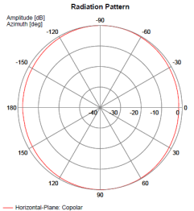

Figure 3: Cab-radio horizontal antenna pattern at 880 MHz

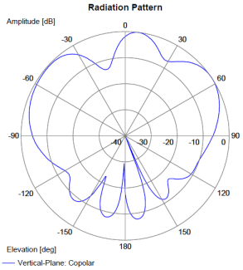

Figure 4: Cab-radio vertical antenna pattern at 880 MHz

# Coexistence between RMR cab-radio and MFCN in the 900 MHz range

This section aims at determining the robustness required for the RMR cab-radio, i.e. the maximum interfering signal level from MFCN BS and MFCN “aerial UE” that a cab-radio must be able to face.

## Coexistence between RMR cab-radio and MFCN BS above 925 MHz

### Blocking and intermodulation

Based on UIC’s report O-8736 [6] where field measurements of emissions from UMTS BS and a potential increase of MFCN BS EIRP in the long term when moving to 10 MHz channels (as described in Report ITU-R M.2292-0 Table 3 [5]) are documented, ETSI TS 102 933-1 v1.3.1 [7] onwards has specified an enhanced blocking / intermodulation threshold for GSM-R cab-radios so that they are able to cope with MFCN emissions above 925 MHz.

Table 6: GSM-R improved cab-radio receiver characteristics

|  |  |
| --- | --- |
| Parameter | Value |
| Sensitivity | -104 dBm |
| Level of the wanted signal | -101 dBm  = Sens + 3 dB |
| Maximum CW interfering signal in 925.6-927 MHz | -13 dBm |
| Maximum CW interfering signal in 927-960 MHz | -10 dBm |
| Maximum 5 MHz LTE interfering signal (lowest carrier at 927.6 MHz) | -13 dBm |
| Note 1: The antenna connector of the radio module is the reference point.  Note 2: These requirements cover both blocking and third-order intermodulation. | |

These requirements remain valid and can be directly applied to FRMCS cab-radios.

### Considerations on RMR minimum signal level and radio planning level

#### Derivation of the ACS value

Interference resulting from limited selectivity of a radio receiver can be modelled by a power level, denoted $I_{R}$, degrading the signal over noise power ratio:

$$\frac{S}{NF+I_{R}}$$

The interfering power within the receiver $I_{R}$ can be expressed as function of the interfering at the antenna connector:

$$I_{R}=\frac{I}{A}$$

Where the selectivity “A” is the value of an intrinsic characteristic of the receiver that reflects its level of immunity to the interference. The selectivity can be derived from the Requirements on FRMCS cab-radio receiver characteristics as follows:

When operating at the receiver sensitivity, in a noisy environment, the signal to noise power ratio is given by:

$$\frac{S_{sensitivity}}{NF}={SNR}_{sensitivity}$$

When operating under the conditions described by the requirement, the signal to noise power ratio is given by:

$$\frac{S_{sensitivity}×{10}^{3/10}}{NF+I/A}= {SNR}_{sensitivity}$$

This equation represents a densitisation of 3 dB when subject to a given interference power $I$ at the antenna connector.

By dividing the two expressions above, we obtain the following equation for A, expressed in dB scale:

$$A=I-NF-10×\log_{10}\left({10}^{\frac{3}{10}}-1\right)$$

By application of the values proposed in Table 3, the following is obtained:

$$A=89 dB$$

With $I=-13 dBm$ and $F=$ 5 dB.

#### Minimum wanted signal level at cab-radio antenna connector

In order to maintain a given performance target, the signal over noise power ratio must be greater than a target value denoted ${SNR}_{target}$:

$$\frac{S_{minimum}}{NF+I_{R}}≥{SNR}_{target}$$

Which is equivalent to the following inequation in dB scale:

$$S_{minimum, dB}≥ {SNR}_{target, dB}+10×\log_{10}(NF+I_{R})$$

For a LTE 5 MHz interfering signal, transmitted with common eirp level of 60 dBm, taking into account losses from the MFCN BS to the cab-radio and the selectivity derived above, $I_{R}$ is typically around:

$$I_{R}=\left(60-69\right)-89$$

$$= -98 dBm$$

Therefore, the minimum FRMCS signal level at the cab-radio antenna connector must be above the following target:

$$S_{minimum, dB}=-90.94 dBm$$

This is obtained with ${SNR}_{target}=5.6 dB$ (referring to A2.4).

It is worth highlighting that this is the minimum power level at the antenna connector, but because the wanted signal is varying due to random nature of the propagation channel, an adequate margin must be applied to obtain the planning level. The derivation is given in the following section.

#### Corresponding level for radio planning

It is typical to assume that a power level can be modelled with a lognormal random value, with parameters $σ^{2}$ and median value $S_{planning}$ is the planning level.

The propagation channels are geographically correlated which, in the case of FRMCS, is a one-dimensional stochastic process along the tracks. While the interference power can be significant over a few tens of meters, the typical decorrelation distance of radio channels is lower than 10 meters[4]. It is therefore possible to infer that no more than 10 independent random values are encountered on the interference zone. The median FRMCS planning level must be such that:

$$P\left\{X_{1}\left(S_{planning},σ^{2}\right)<S_{minimum,dB}U…U X_{10}\left(S_{planning},σ^{2}\right)<S_{minimum,dB}\right\}≤ P_{interference}$$

Where:

* $P(E)$ is the probability of the event E.
* Xi(.,.) are ten independent random values normally distributed.
* $P_{interference}$ is acceptable interference probability, e.g. 0.01 for 1%.

The above equation is equivalent to:

$P\left\{X_{i}(S_{planning},σ^{2})≥S_{minimum,dB}\right\}>\sqrt[10]{1-P_{interference}}$

* For $P_{interference}=0.01$, the right-hand side of the above equation is equal to 0.999.

From the table of a normally distributed random value, the following is obtained:

$$S_{planning}=S_{minimum, dB}+3.08×σ$$

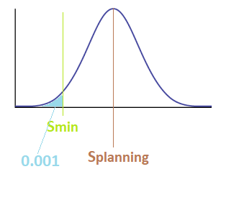

Assuming further that the standard deviation of the shadowing is equal to 5.5 dB, the planning level for the radio planning should be:

$$S_{planning}= -74 dBm/5MHz$$

### Impact of MFCN unwanted emissions on FRMCS cab-radio

In this study, a worst-case analysis is performed to compute the amount of the interference-to-Noise Ratio ( $I-{N)}_{calculated}$ at the FRMCS cab-radio victim receiver caused by a MFCN base station in close vicinity. The FRMCS cab-radio is operating in 919.4-925 MHz and the MFCN base station interferer is operating in the channel above 925 MHz. In this study distances from 0 m to 1200 m are considered between the MFCN base station and the cab-radio victim receiver. The antenna gain of the MFCN base station in the direction of the train is accounted for by using the formulas from the Reccommendation ITU-R F.1336-5 [20]. For the propagation model, describing the attenuation of the radio signal along the propagation path, the modified Hata model is used that is presented in the ERC Report 68. In this connection, open area, suburban and urban environments are distinguished.

The results of the study indicate that the ( $I-{N)}_{target}=0 dB$ will be exceeded for quite some ranges of parameters. However, it should be noticed that the study gives the results for a worst case in which the antenna beam of the MFCN interferer is pointing directly onto the rail tracks. So, it is assumed that the victim is situated inside of the main beam range in the azimuth plane. The interference situation will be improved accordingly in cases where the victim is located in a side-lobe region but not inside of the main beam lobe of the interferer.

#### Assumptions on parameters

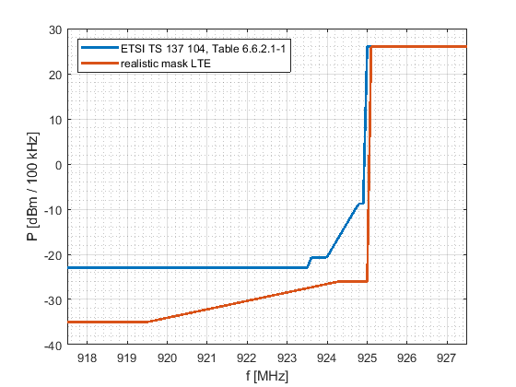

Figure 5: Sketch of the emission levels of the LTE transmit masks given by an ETSI standard (blue curve) and a measurement report (red curve)

The realistic LTE mask is based on a real LTE base station currently in use where the unwanted emission suppression is better than the corresponding standard requires.

In this study, we consider limits for the unwanted emissions of an LTE MFCN base station given in the document ETSI TS 136 104 in Table 6.6.3.1-3 [21] that read for a measurement bandwidth of 100 kHz:

Table 7: LTE MFCN base station emission mask

|  |  |
| --- | --- |
| Frequency offset of measurement filter centre frequency, f_offset | Minimum requirement per 100 kHz |
| 0.015 MHz ≤ f_offset < 0.215 MHz | -8.78 dBm |
| 0.215 MHz ≤ f_offset < 1.015 MHz | -8.78 dBm -15 $∙\left(\frac{f_offset}{MHz}-0.215\right)$ dB |
| 1.015 MHz ≤ f_offset < 1.5 MHz | -20.78 dBm |
| 1.5 MHz ≤ f_offset ≤ 10 MHz | -23 dBm |

For the inblock power of the MFCN base station, a value of P = 26 dBm/100 kHz is assumed.

It is further considered an expression for an LTE emission mask determined by measurements and given in the document FM(13)134 ”GSM-R measurement report by BNetzA” in section 3.4 where the average over the measurements data reads as follows:

Table 8: Realistic LTE MFCN base station mask based on measurement

|  |  |
| --- | --- |
| Frequency point [MHz] | Absolute level [dBm] per 100 kHz |
| 917.5 | -35 |
| 919.5 | -35 |
| 924.3 | -26 |
| 925 | -26 |
| 925.1 | 26 |
| 927.5 | 26 |

This mask will be named as ”realistic mask” in the following, as actual LTE base stations usually reach a higher suppression of unwanted emissions than the standard requires. Further, the LTE signals used in the measurements were configured according to a test model representing the worst case for the victim because it occupies all the available resource blocks at maximum power. Based on practical experiences an LTE signal is pulsed and has high out-of-band emissions only during short times. Therefore, it has less interference potential than the fully loaded signal according to the test model (see the description in the document FM(13)134, section 3.4).

In the study, the following characteristics were assumed for the MFCN base station:

Table 9: LTE MFCN base station characteristics

|  |  |  |
| --- | --- | --- |
|  | Open area case | Urban/suburban cases |
| h_basestation | 45 m | 30 m |
| Downtilt | 3° | 10° |
| G0 | 17 dBi | 15 dBi |

For the cab-radio, a height of h_cab-radio = 4 m is assumed.

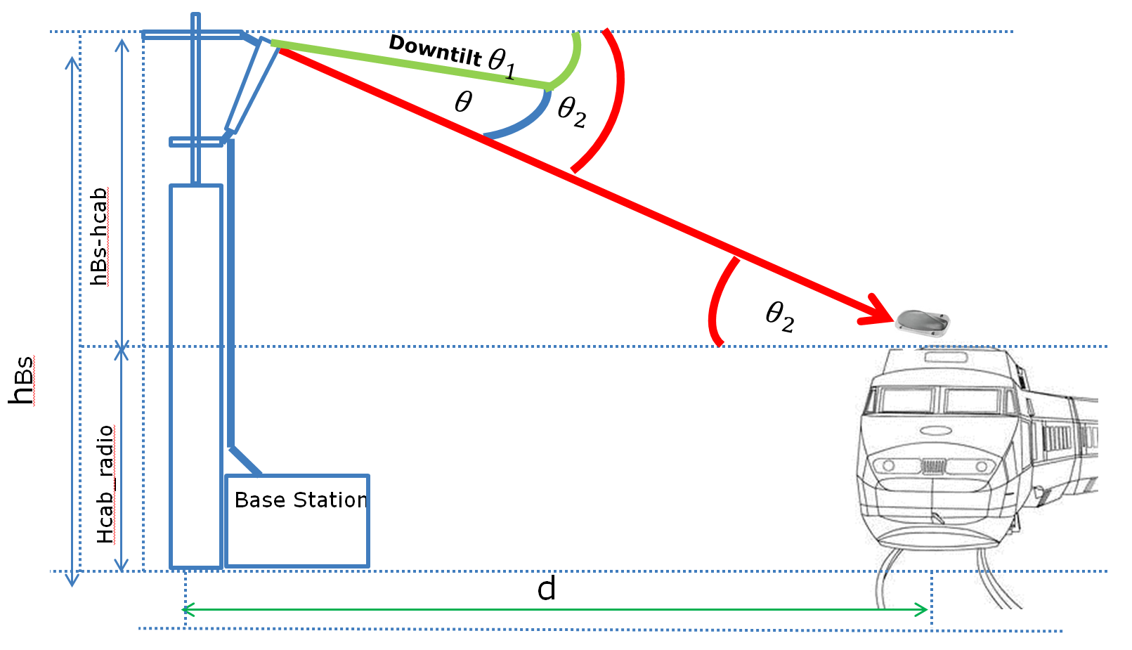

Figure 6: Illustration of the scenario

A scenario with distances ranging from d = 0 m to d = 1200 m between the MFCN base station is considered, and the train tracks at which the FRMCS cab-radio is located, as illustrated in the graphic above. The angle $θ$ is relevant to determine the deviation from the maximum antenna gain in the elevation plane for the MFCN base station.

#### Antenna gain of the MFCN base station in the direction of the cab-radio

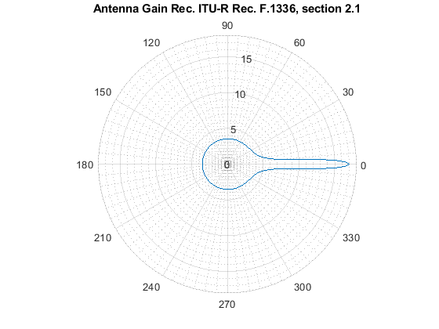

Figure 7: Plot of the formula for $G\left(θ\right)$ as given below

To describe the antenna pattern of the MFCN base station we use the ”peak side lobe pattern” given in the Reccommendation ITU-R F.1336-5 [20] in section 2.1 that is given by the following formula:

$$G\left(θ\right)=\left\{\begin{aligned}G_{0}-12{\left(\frac{θ}{θ_{3}}\right)}^{2} for 0 ≤\left|θ\right|<θ_{4} \\ G_{0}-12+10 log\left(k+1\right) for θ_{4} ≤\left|θ\right|<θ_{3} \\ G_{0}-12+10 log\left[{\left(\frac{\left|θ\right|}{θ_{3}}\right)}^{-1.5}+k\right] for θ_{3} ≤\left|θ\right|<90°\end{aligned}\right.$$

with

$$θ_{3}=5°$$

$θ_{4}$ = $θ_{3}\sqrt{1-\frac{1}{1.2}log\left(k+1\right)}$

where

* $G\left(θ\right):$ gain relative to an isotropic antenna (dBi);
* $G_{0}:$ maximum gain in the azimuth plane (dBi);
* $θ:$ elevation angle relative to the angle of the maximum gain (degrees) (-90° ≤ $θ≤90°$);
* $θ_{3}:$ the 3 dB beamwidth in the elevation plane;
* k: parameter which accounts for increased side-lobe levels above what would be expected for an antenna with improved side-lobe performance. In the present case there is k=0.7.

Considering the sketch above, the angle $θ$ that is relevant to compute the reduction from the maximum value for the antenna gain G0 reads as follows:

$$θ = θ_{2}-θ_{1}=\tan^{-1}\left(\frac{h_{basestation}-h_{cabradio}}{d}\right)-θ_{1}$$

Where:

* $θ_{1}$ is the downtilt of the antenna at the MFCN base station;
* $θ_{2}$ is the angle between the horizontal plane and the connection line between the MFCN base station and the cab-radio.
* With the above given formula for $G(θ)$, the antenna gain in the direction of the connection line between the MFCN base station and the cab-radio can be derived.

The results show that the maximum antenna gain $G_{0}$ is reduced by values ranging from $≈0$ dB to -13.4 dB depending on the angle $θ$.

#### Propagation path loss

To compute the path loss of the radio signal propagating between the MFCN base station and the cab-radio, the modified Hata model is used which is described in the ERC Report 68 on the page 21. In the evaluation, the frequency is set to f = 925 MHz.

For the parameter h_basestation, the cases of urban, suburban and open area environments have to be distinguished.

For distances d ≤ 40 m, the propagation loss is given by

$$L_{pathloss}\left[dB\right]=32.45+20∙\log\left(f\right)+10∙{\log{(\left(d\left[km\right]\right)}}^{2}+\frac{{\left(h_{basestation}-h_{cabradio}\right)}^{2}}{{10}^{6}})$$

For d≥ 100 m, the modified Hata model reads for the respective scenarios:

Urban case:

$$L_{pathloss,urban}\left[dB\right]=69.6+26.2∙\log\left(f\right)-13.82∙\log\left(h_{basestation,urban}\right)+\left(44.9-6.55∙\log\left(h_{basestation,urban}\right)\right)∙\log\left(d\left[km\right]\right)-a\left(h_{cabradio}\right)$$

$$a\left(h_{cabradio}\right)=\left(1.1∙\log\left(f\right)-0.7\right)∙h_{cabradio}-(1.56∙\log\left(f\right)-0.8)$$

Suburban case:

$$L_{pathloss,suburban}\left[dB\right]=L_{urban}\left[dB\right]-2∙{\left(\log\left(\frac{f}{28}\right)\right)}^{2}-5.4$$

Open area case:

$$L_{pathloss,freespacce}\left[dB\right]=32.45+20\log\left(f\right)+20 log⁡(d[km])$$

In the open area case, the pathloss is given by the free space propagation model.

For the case of 40 m < d < 100 m, the path loss is interpolated by:

$$L_{pathloss}\left[dB\right]=L_{pathloss}\left(0.04\right)+\frac{\left(\log\left(d\left[km\right]\right)-\log\left(0.04\right)\right)}{\left(\log\left(0.1\right)-\log\left(0.04\right)\right)}∙\left(L_{pathloss}\left(0.1\right)-L_{pathloss}\left(0.04\right)\right),$$

where for $L_{pathloss}\left(0.04\right), L_{pathloss}(0.1)$ the formulas for the respective cases of open area, suburban and urban environments have to be used. The graphic below illustrates the predictions of the propagation model. For example, for d = 100 m the path loss is 71.8 dB for the open area case, 75.2 dB for the suburban case and 85.3 dB for the urban case, so that the difference can amount up to 13.5 dB.

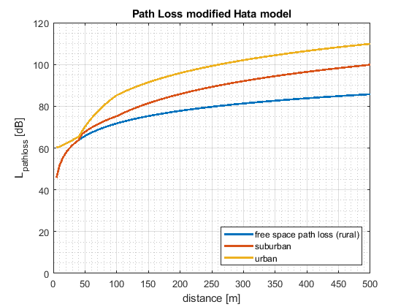

Figure 8: Propagation path loss predicted according to the modified Hata model

#### Interference calculation

In the present study, a worst-case analysis is performed. The following is computed:

$$I-N=P_{MFCN,transmitmask}+G{\left(θ\right)}_{MFCN,i}-L_{pathloss,i}-L_{feeder}-N$$

Where:

* i=urban, suburban, openarea environments for the propagation model;
* $I:$ power levels received at the cab-radio;
* $N:$ noise power level at the receiver;
* $P_{MFCN,transmitmask}$: power levels from the transmit masks of the MFCN base station;
* $L_{feeder}=$ 3 dB feeder loss of the cab-radio;
* $G{\left(θ\right)}_{MFCN,i}:$ antenna gain as explained above for the respective scenarios i= urban, suburban, openarea.

The results can be compared with a protection criterion as follows:

$$(I-{N)}_{target}=0 dB$$

that corresponds to an allowed degradation margin of 3 dB for the cab-radio. For a bandwidth of 100 kHz and a noise figure for the cab-radio as NF_cab-radio = 4 dB, the noise level N in the expression can be computed as:

$$N\left[\frac{dBm}{100 kHz}\right]=-174\frac{dBm}{Hz}+10∙\log\left({10}^{5}\right)+NF= -120\frac{dBm}{100 kHz}$$

#### Duration of the interference

In a scenario where the main beam of the MFCN base station is pointing onto the rail tracks in a rectangular way and where the azimuth beamwidth is assumed to be 62°, a train with the velocity v will be situated inside of the main beam region for the respective times:

$$t=\frac{b}{v}$$

Table 10: Interference time depending on distance and train speed

|  |  |  |
| --- | --- | --- |
| d [m] | t [sec] for v=80 km/h | t [sec] for v=150 km/h |
| 100 | 5.4 | 2.9 |
| 250 | 13.5 | 7.2 |

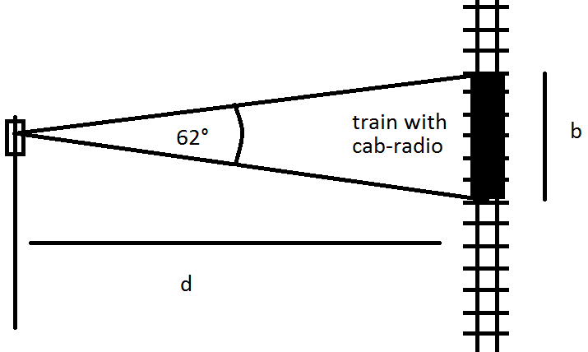

Figure 9: Scenario to determine the interference time t

#### Results

In the following, the results of the above described analysis are presented.

In the first plots below, the amount of the interference is illustrated in terms of the $(I-{N)}_{calculated}$ in [dB] in dependence of the frequency range for the cases of d = 100 m and 250 m between the MFCN base station and the cab-radio victim receiver.

It should be noticed that the study gives the results for the worst case in which the antenna beam of the MFCN interferer is pointing directly onto the rail tracks. In this scenario, the victim is situated inside of the main beam range in the azimuth plane. The interference situation will be improved accordingly in cases where the victim is located in a side-lobe region but not inside of the main beam lobe of the interferer. In this worst-case situation, the $(I-{N)}_{target}=0 dB$ will be exceeded for quite some ranges of parameters. At the frequency f = 922.5 MHz, the $(I-{N)}_{calculated}$ reads in [dB]:

Table 11: Calculated Interference to Noise ratios at different environments

|  |  |  |  |
| --- | --- | --- | --- |
|  |  | Standard mask $$(I-{N)}_{calculated}$$ | Realistic mask $$(I-{N)}_{calculated}$$ |
| d = 100 m | Open area | 26.43 | 20.05 |
| Suburban | 24.07 | 17.69 |
| Urban | 14.05 | 7.67 |
| d = 250 m | Open area | 20.74 | 14.37 |
| Suburban | 11.83 | 5.45 |
| Urban | 1.81 | -4.57 |

In the last two plots, the $(I-{N)}_{calculated}$ is illustrated for the power level per 100 kHz at f = 922.5 MHz in dependence of the distance d between the interferer and the victim. In these graphics, the kinks are stemming from the distinction of cases in the formula for the antenna gain $G(θ)$ as described above in the second subsection of this study. In the formula for $(θ)$, the angles $θ$ are varying with the distance d between the MFCN base station and the cab-radio.

Considering urban and suburban environments, the emissions according to the ETSI mask are reduced sufficiently after distances of around 260 m and 450 m. For the emission mask averaging the measurements results, the emissions can be reduced sufficiently after distances of around 220 m and 310 m. For the open area case, the situation is more critical. Nevertheless, it should be noticed that the propagation loss of the radio signal is given by the free space propagation model in the open area case, representing very pessimistic interference conditions.

#### Conclusions

The results of the study should be considered in the planning procedure for the FRMCS system. Filtering systems can be considered to mitigate the higher emission levels of the MFCN interferer close to the FRMCS channel to avoid interferences. The study gives the results for worst-case situations, where the MFCN base station operates in close vicinity to the railway tracks and the main beam of the MFCN base station is hitting directly onto the railway tracks. In practice measures like operator agreements and coordinated deployments could be used to ensure the compatibility of both MFCN and FRMCS in parallel.

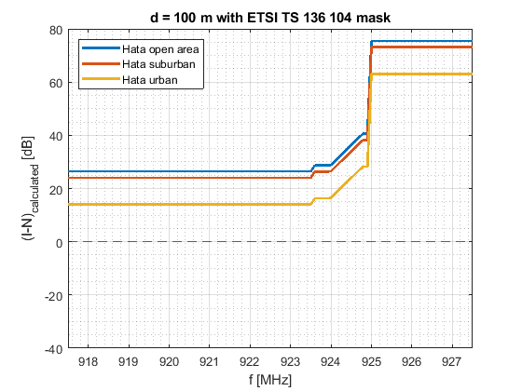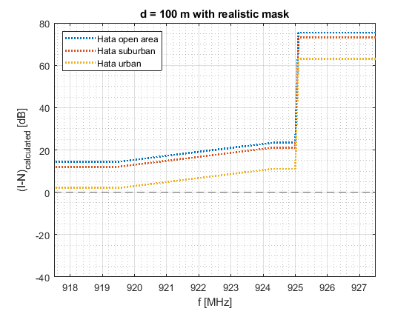

Figure 10: I-N caused by the MFCN interferer at the cab-radio victim receiver for a distance of 100 m between the MFCN base station and the victim receiver, for the emission mask according to ETSI TS 137 104 and the emission mask determined by measurements, respectively

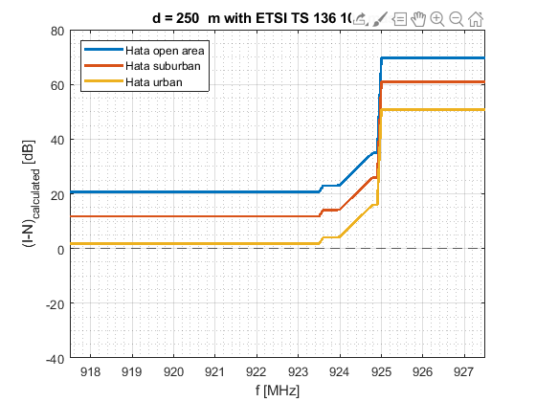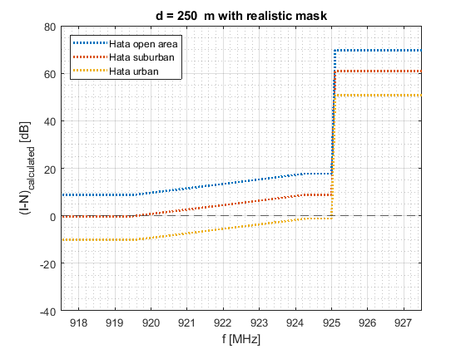

Figure 11: I-N caused by the MFCN interferer at the cab-radio victim receiver for a distance of 250 m between the MFCN base station and the victim receiver, for the emission mask according to ETSI TS 137 104 and the emission mask determined by measurements, respectively

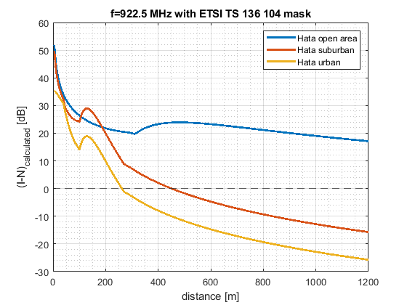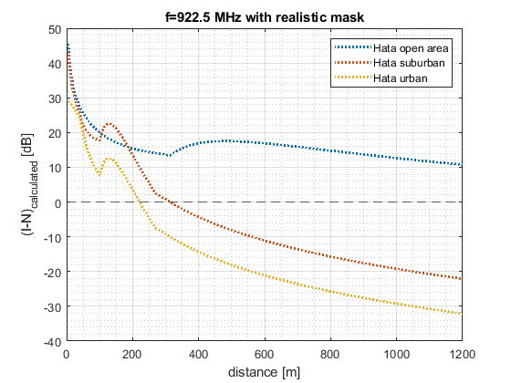

Figure 12: I-N caused by the MFCN interferer at the cab-radio victim receiver in dependence of the distance between the MFCN base station and the victim receiver at the frequency level f = 922.5 MHz, for the emission mask according to ETSI TS 137 104 and the emission mask determined by measurements, respectively

### 4.1.4 MFCN out-of-band emissions at RMR cab-radio max blocking signal level

[In chapter 4.1.1 it is said that RMR cab-radio shall tolerate LTE BS signal at 927.6 MHz level of -13 dBm. At the same time MFCN BS may emit out-of-band emission to channel on which RMR cab-radio receive. Based on ETSI TS 137 104 adjacent channel leakage radio (ACLR) of MFCN base station, this level is allowed to be 45 dB lower than its wanted signal.

As an example, one MFCN BS signal is at level of -13 dBm exist at connector of RMR cab-radio. Then out-of-band emission from MFCN BS at RMR channel could be at level of -13 dBm – 45 dB = -58 dBm if there are not any additional measures. Thermal noise power at 4,5 MHz bandwidth is -107.5 dBm and this -58 dBm level of out-of-band emission is 49.5 dB higher than thermal noise level at RMR cab-radio connector.]

1. The section 4.1.4 is expected to be reviewed and revised during the public consultation.

## Coexistence between RMR cab-radio and MFCN aerial UE below 915 MHz

According to ECC Report 309, the term “aerial UE” is equally applicable to unmanned aircraft (drone) and manned aircraft.

**Aerial UE characteristics:**

* Max output power: 23 dBm;
* Antenna gain: 0 dBi (cf. draft ECC Report 309)

When assuming an MFCN aerial UE at 30 m separation distance[5] from the cab-radio (expected to be the minimum exclusion zone from rail tracks), the maximum interfering power *Max_IIB* that a cab-radio must be able to face at its antenna connector can be calculated from the following formula:

$$AerialUE_EIRP -L=Max_I_{IB}$$

$$L=PL-G_{cab-radio}+HWlosses$$

where *PL* is the free space path loss, *Gcab-radio* is the cab-radio antenna gain of 5 dBi, and HW losses are 3 dB.

$$Max_I_{IB}=23-61.2+5-3=-36.2 dBm$$

As seen in Annex 2, the maximum acceptable desensitization for an FRMCS cab-radio (worst case compared to GSM-R) is 1.7 dB. Thus, the maximum MFCN aerial UE interfering signal below 915 MHz that an RMR cab-radio may face is -36.2 dBm for a desensitization of 1.7 dB. In order to be able to cope with MFCN aerial UE, the following receiver characteristics are required for RMR cab-radios.

Table 12: Requirements on RMR cab-radio receiver characteristics

|  |  |
| --- | --- |
| Parameter | Value |
| Level of the wanted signal | Sens + 3 dB |
| Maximum 5 MHz LTE interfering signal in 880-915 MHz (Note 2) | -33 dBm[6] |
| Note 1: The antenna connector of the radio module is the reference point.  Note 2: This requirement covers both blocking and third-order intermodulation | |

These requirements are already fulfilled by GSM-R cab-radios specified in ETSI TS 102 933-1 [7] (≥ -12 dBm below 915 MHz).

# Coexistence between RMR cab-radio and SRD below 919.4 MHz

This section aims at determining the robustness required for the RMR cab-radio, i.e. the maximum interfering signal level from SRD that a cab-radio must be able to face given that the spectrum should be used to maximum efficiency. Full technical characteristics of SRD considered in this Report are given in Annex 3.

ECC Report 200 assessed the impact of SRD unwanted emissions on GSM-R terminals based on the assumptions available at that time; some parameters are not up to date (e.g. C/(N+I)), antenna height, propagation model, etc.) and FRMCS was not considered.

## 500 mW SRD

In this study, worst-case scenarios (meaning not typical) for RMR cab-radios are considered where 500 mW SRD are in close proximity to rail tracks, in direct line-of-sight and of the following types:

* NAP placed above rooftop;
* NN (outdoor relay nodes) placed at 5 m height.

Table 8: 500 mW SRD characteristics

|  |  |  |
| --- | --- | --- |
| Parameter | Value | Comment |
| Upper channel | 918.5-918.9 MHz |  |
| Bandwidth | 1 kHz to 200 kHz |  |
| Maximum e.r.p. | 500 mW |  |
| Maximum e.i.r.p. | 29.1 dBm |  |
| Antenna height | NAP: 25 m *1  NN: 5 m *2 | *1 valid for CSS and UNB  *2 valid for NBN  (There are 2 other type of devices emitting at 500 mW which are not considered in this section:  - NBN NAP at 7 m  - NBN TN at 1.5 m) |

### 500 mW SRD NAP above rooftop

For certain types of data networks, NAP are installed at up to 25 m; then the coexistence scenario for a 500 mW SRD NAP is above rooftop. In other cases, NAP are installed at 7 m or 5 m, so is below rooftop (see section 5.1.2). The worst-case scenario of a NAP at 25 m height is considered here and is similar to coexistence between MFCN BS (also above rooftop) and RMR cab-radio.

From Report ITU-R M.2292-0 [5] and ETSI TS 102 933-1 [7], the loss *L* between the MFCN BS EIRP[7] and the maximum interfering power received at the cab-radio antenna connector *Max_IIB*[8] (defined for a desensitization of 3 dB) can be deduced.

$$MFCN_BS_EIRP -L=Max_I_{IB}$$

$$L=MFCN_BS_EIRP-Max_I_{IB}=58-\left(-13\right)=71 dB$$

The same loss is applied between the NAP e.i.r.p. and the interfering power received at the cab-radio antenna connector.

$$Max_I_{IB}=NAP_EIRP-CL=29.1-71=-41.9 dBm$$

In order to cope with 500 mW NAP above rooftop, the maximum interfering signal below 918.9 MHz for RMR cab-radios shall be -42 dBm for a desensitization of 3 dB.

### 500 mW NN at 5 m height

The purpose of this section is to assess whether a maximum interfering level of -39 dBm is sufficient for RMR cab-radios to cope with 500 mW NN at 5 m height.

When assuming 25 m separation distance, the loss *L* between the NN and the cab-radio can be described as follows:

$$L=PL-G_{cab-radio}+HWlosses$$

where $G_{cab-radio}$ is assumed to be 0 dBi since the elevation angle from the cab-radio is close to 0°. HW losses are 3 dB (cf. Table 5). The free space propagation model is used.

$$PL=59.6 dB$$

$$L=59.6-0+3=62.6 dB$$

The loss is 8.4 dB lower than the one related to the NAP above rooftop. Thus, in order to cope with 500 mW NN below rooftop, the maximum interfering signal below 918.9 MHz for RMR cab-radios shall be -33.5 dBm (= -41.9 + 8.4) for a desensitization of 3 dB.

This section is also valid for NAP below rooftop.

### Receiver requirements for RMR cab-radio below 918.9 MHz

In order to face a potential densification of 500 mW SRD along rail tracks, a margin of 3 dB is added to the maximum interfering signal below 918.9 MHz for RMR cab-radios. Based on worst-case scenarios, the following receiver characteristics are thus required for RMR cab-radios.

Table 14: Requirements on RMR cab-radio receiver characteristics

|  |  |
| --- | --- |
| Parameter | Value |
| Level of the wanted signal | Sens + 3 dB |
| Maximum interfering signal in 916.1-918.9 MHz (Note 2) | -30.5 dBm |
| Note 1: The antenna connector of the radio module is the reference point.  Note 2: This requirement covers both blocking and third-order intermodulation. | |

## RFID

When considering the impact of RFID interrogator on RMR cab-radio, three worst case scenarios are studied (outdoor cases are considered here and indoor case in 5.2.1):

* an horizontal interrogator to scan containers from above the truck (1);
* a vertical interrogator facing the opposite direction of the rail tracks (2);
* a vertical interrogator facing the rail tracks (3).

|  |  |
| --- | --- |
| (1) | |
| (2) | (3) |

Figure 13: RFID outdoor scenarios

These scenarios reflect RFID use cases expected in private sidings connected to the main railway network, like in container storage areas, intermodal freight nodes, etc.

Table 15: RFID interrogator characteristics (heights and distances for different scenarios)

|  |  |
| --- | --- |
| Parameter | Value |
| Frequency ranges | 916.1-916.5 MHz  917.3-917.7 MHz  918.5-918.9 MHz |
| Bandwidth | 400 kHz |
| Maximum e.r.p. | 4 W |
| Maximum e.i.r.p. | 38.2 dBm |
| Antenna | Laird™ PAV90209H |
| Antenna height | 4.5 m for (1)  2.4 m for (2) and (3) |
| Maximum antenna gain | 9 dBi |
| Front to back ratio | 18 dB |
| Ground distance from rail tracks | 25 m for (1) and (3)  20 m for (2) |

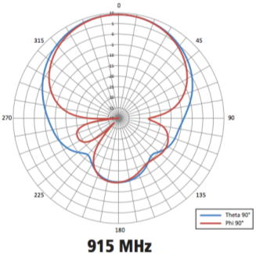

Figure 14: RFID interrogator antenna pattern  
Theta = vertical plane / Phi = horizontal plane when the interrogator is placed vertically

The maximum interfering power *Max_IIB* that a cab-radio must be able to face at its antenna connector can be calculated from the following formula:

$$RFID_EIRP -L=Max_I_{IB}$$

$$L=PL+D_{RFID}-G_{cab-radio}+HWlosses$$

where *PL* is the free space path loss, *DRFID* is the RFID antenna discrimination depending on the scenario considered, *Gcab-radio* is the cab-radio antenna gain including the discrimination and depending on the scenario considered, and HW losses are 3 dB.

|  |  |
| --- | --- |
| In scenario (1):   * *PL* = 59.6 dB * *DRFID* = 35 dB * *Gcab-radio* = 0 dBi * *L* = 97.6 dB * *Max_IIB* = -59.4 dBm | In scenario (2), reflection on the container:   * *PL* = 58.5 dB with 2 m additional propagation distance towards/from the container (due to reflection) * *DRFID* = 6 dB to account for the reflection loss * *Gcab-radio* = 0 dBi * *L* = 67.5 dB * *Max_IIB* = -29.3 dBm |
| In scenario (2), backwards emissions:   * *PL* = 57.7 dB * *DRFID* = 18 dB * *Gcab-radio* = 0 dBi * *L* = 78.7 dB * *Max_IIB* = -40.5 dBm | In scenario (3):   * *PL* = 59.6 dB * *DRFID* = 0 dB * *Gcab-radio* = 0 dBi * *L* = 62.6 dB * *Max_IIB* = -24.4 dBm |

As seen in Annex 2, the maximum acceptable desensitization for an FRMCS cab-radio (worst case compared to GSM-R) is 1.7 dB. Scenario (2) is used to define the maximum RFID interfering signal below 918.9 MHz that an RMR cab-radio may face, i.e. -29.3 dBm for a desensitization of 1.7 dB. In order to be able to cope with 4 W RFID interrogators in worst case situations, the following receiver characteristics are required for RMR cab-radios.

Table 16: Requirements on RMR cab-radio receiver characteristics

|  |  |
| --- | --- |
| Parameter | Value |
| Level of the wanted signal | Sens + 3 dB |
| Maximum RFID interfering signal in  916.1-918.9 MHz (Note 2) | -26 dBm[9] |
| Note 1: The antenna connector of the radio module is the reference point.  Note 2: This requirement covers both blocking and third-order intermodulation. | |

### RFID indoor operation

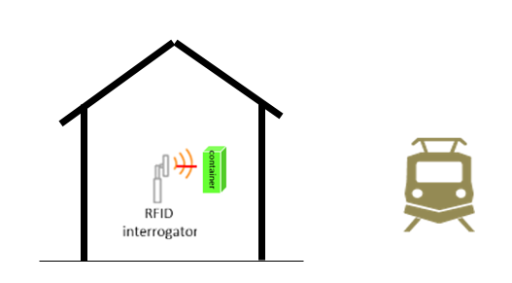(4)

Figure 15: RFID indoor scenario

In scenario (4), indoor operation:

* *PL* = 59.6 dB for 25 m ground distance;
* *DRFID* = 0 dB;
* *Wall loss* = 7 dB in store / item tagging scenario (see A3.2);
* *Gcab-radio* = 0 dBi;
* *L* = 69.6 dB;
* *Max_IIB* = -40.4 dBm with 27 dBm e.r.p. RFID interrogators in store / item tagging scenario (see A3.2).

As seen in Annex 2, the maximum acceptable desensitization for an FRMCS cab-radio (worst case compared to GSM-R) is 1.7 dB. Based on the table above, for typical indoor operation, RMR cab-radios may normally face -42.6 dBm.

## Other 25 mW SRD

The loss *L* between the 25 mW SRD and the cab-radio can be described as follows:

$$L=PL-G_{cab-radio}+HWlosses$$

where *PL* is the path loss for 20m separation distance (worst case), $G_{cab-radio}$ is -5 dBi (below horizontal plane in Figure 4), HW losses are 3 dB (cf. Table 5). The 25 mW short-range device is considered outdoor while in most cases they are inside a building. The free space propagation model is used.

$$PL=57.7 dB$$

$$L=57.7-(-5)+3=65.7 dB$$

The maximum interfering power received at the cab-radio antenna connector *Max_IIB* can be deduced.

$$Max_I_{IB}=SRD_EIRP-L=16.1-65.7=-49.6 dBm$$

As seen in Annex 2, the maximum acceptable desensitization for an FRMCS cab-radio (worst case compared to GSM-R) is 1.7 dB. Based on the table above, the maximum 25 mW SRD interfering signal below 919.4 MHz that an RMR cab-radio may face is -49.6 dBm for a desensitization of 1.7 dB. In order to be able to cope with 25 mW SRD, the following receiver characteristics are required for RMR cab-radios.

Table 17: Requirements on RMR cab-radio receiver characteristics

|  |  |
| --- | --- |
| Parameter | Value |
| Level of the wanted signal | Sens + 3 dB |
| Maximum interfering signal in  918.9-919.4 MHz (Note 2) | -46 dBm[10] |
| Note 1: The antenna connector of the radio module is the reference point.  Note 2: This requirement covers both blocking and third-order intermodulation. | |

This value could be relaxed by 17 dB with respect to SRD operating indoor. This would lead to a blocking level of -63 dBm, whih is already fulfilled by both GSM-R and LTE/NR specifications. Considering:

* the elements above;
* that the requirement of a blocking level of -26 dBm below 918.9 MHz could lead to some additional filtering in 918.9-919.4 MHz.

It is considered not necessary to define a specific requirement on RMR receivers in 918.9-919.4 MHz.

## Specific case of GSM-R operating at 919.6 MHz

The lowest GSM-R carrier within the band is centred at 919.6 MHz.

In ETSI TS 145 005, Table 6.3-1 in section 6.3 [23], protection ratios are specified in dB for a desensitization DSTANDARD of 20 dB (see section 6.1):

* Co-channel, [C/Ic]dB = 9 dB;
* First adjacent channel, [C/Ia1]dB = -9 dB.

The selectivity can be obtained by the following formula in dB:

$$S_{a1}=I_{a1}-I_{c}=\left[C/{I_{c}}\right]-\left[C/{I_{a1}}\right]=18 dB$$

When considering a desentisation of 2.2 dB (cf. Annex 2) and a noise figure of 5 dB (cf. Table 5), the associated blocking level is -99.8 dBm.

The loss *L* between the SRD e.i.r.p. and the maximum interfering power received at the cab-radio antenna connector *Max_IIB* is given by the following formulas.

$$L=SRD_EIRP-Max_I_{IB}$$

where $SRD_EIRP$ is 16.1 dBm (25mW ERP).

$$L=115,9 dB$$

When the 25 mW SRD operate indoor, an additional wall loss of 17 dB should be taken into account, giving a loss of 98.9 dB. The number of SRD in close proximity to rail tracks is supposed to be a low proportion.

In some worst case scenarios in close proximity to the rail tracks, the GSM-R cab-radio receiving at 919.6 MHz may face harmful interference from 25 mW SRD due to blocking.

## Overall requirements on RMR cab-radio receiver characteristics with respect to SRD

In order to be able to cope with SRD emissions below 919.4 MHz, the following receiver characteristics are required for RMR cab-radios.

Table 18: Requirements on RMR cab-radio receiver characteristics

|  |  |
| --- | --- |
| Parameter | Value |
| Level of the wanted signal | Sens + 3 dB |
| Maximum interfering signal in  916.1-918.9 MHz (Note 2) | -26 dBm |
| Note 1: The antenna connector of the radio module is the reference point.  Note 2: This requirement covers both blocking and third-order intermodulation. It is up to ETSI to define a relevant interfering signal against which the conformity test will be performed. In this Report, the RFID interfering signal considered is 400 kHz wide. | |

Improved GSM-R cab-radios as per ETSI TS 102 933-1 [7] are currently under deployment and do not fulfil the requirement above. Considering this and the specific equipment life cycle in the railway environment, alternative mitigation techniques, such as to coordinate RFID interrogators at a national level. Hence, the additional requirement in the table above can be made optional in the ETSI specification only for the GSM-R cab-radio.

These SRD and RFID results are based on theoretical calculations and not in a test environment, therefore testing of scenarios may be required to refine the assumptions and results.

## SRD spurious emissions

### RFID interrogators

When considering the worst case scenario (2) for RFID interrogator described in section 5.2, which gives a loss of 67.5 dB, and the maximum co-channel interfering power of -142.2 dBm/kHz that can be accepted by an FRMCS cab-radio at its antenna connector (as seen in Annex 2), the maximum spurious emission level from an RFID interrogator would be -74.7 dBm/kHz.

Currently, the ETSI EN 302 208 (fig 6, page 19 version 3.1.1) [22] allows an unwanted emission level of:

* -36 dBm/kHz in 919.1-919.5 MHz (out-of-band);
* -46 dBm/1 kHz in 919.5-919.7 MHz (out-of-band);
* -36 dBm/100 kHz above 919.7 MHz (spurious).

It is assumed that the scenarios considered in section 5.2 correspond to a duty cycle of 2.5 % (cf. Annex 3). It is considered that a spurious emission limit of -36 dBm/100 kHz from an RFID interrogator should be sufficient to ensure coexistence between RFID interrogators and RMR cab-radios in all cases, including those in private sitings.

The highest RFID interrogator channel is centred at 918.7 MHz, operating in 918.5-918.9 MHz. For FRMCS, the lowest possible RB starts around 919.6 MHz. The spurious level of -36 dBm/100 kHz is fulfilled from 919.7 MHz upwards.

* + 1. **Other SRD**

3GPP-based systems are designed to deal with typical spurious emission levels as specified in ERC/REC 74-01, noting that some specific more stringent requirements are defined within 3GPP for coexistence between BS and UE operating in different frequency bands.

It is thus considered that spurious emission levels defined in ERC/REC 74-01 are sufficient to ensure coexistence of SRD with RMR cab-radios.

# Coexistence between RMR BS and SRD below 874.4 MHz

This chapter aims at determining the robustness required for the RMR BS, i.e. the maximum interfering signal level from SRD that a BS must be able to face. Full technical characteristics of SRD considered in this Report are given in ANNEX 3.

## 500 mW SRD

When considering the characteristics of 500 mW SRD in data networks and the various technologies possible, NAP in some cases are installed below rooftop and the worst case for RMR BS arises when NAP are installed above rooftop. Coexistence between 500 mW NAP above rooftop and RMR BS is similar to coexistence between two MFCN BS (also above rooftop) belonging to two different operators. The technical characteristics are provided in section 5.1.

The maximum interfering power *Max_IIB* that a cab-radio must be able to face at its antenna connector can be calculated from the following formula:

$$NAP_EIRP -L=Max_I_{IB}$$

$$L=PL+D_{Rail}-G_{Rail}$$

where *PL* is free space path loss for 100m, *DRail* is the RMR BS antenna discrimination of 1 dB, *GRail* is the RMR BS antenna gain of 13 dB including the feeder and coupling losses.

$$Max_I_{IB}=NAP_EIRP-CL=29.1-71.2-1+13=-30.1 dBm$$

Editor’s note: This loss value may be updated based on the conclusions of PT1 regarding the coupling loss between MFCN BS and RMR BS at 920 MHz.

### Receiver requirements for RMR BS below 874.4 MHz

In order to cope with 500 mW NAP above rooftop, the maximum interfering signal below 874.4 MHz for RMR BS shall be -30 dBm for a desensitization of 1 dB[11].

Table 14: Requirements on GSM-R and FRMCS BS receiver characteristics

|  |  |
| --- | --- |
| Parameter | Value |
| Level of the wanted signal | Sens + 3 dB |
| Maximum interfering signal in  870-874.4 MHz | -24 dBm |
| Note 1: The antenna connector of the radio module is the reference point.  Note 2: These requirements cover both blocking and third-order intermodulation. It is up to ETSI to define a relevant interfering signal against which the conformity test will be performed. In this Report, the interfering signal considered is 200 kHz wide. | |

## Impact from 500 mW SRD spurious emissions

In this case, the situation is similar to two MFCN operators immediately adjacent to each other in frequency. Hence, as in 3GPP specifications, no specific requirement is needed on 500 mW SRD operating below 874.4 MHz and ERC Recommendation 74-01 should apply.

# Conclusion

The present ECC Report studies the compatibility of Railway Mobile Radio (RMR) in the 900 MHz range with adjacent applications as part of the answer to the mandate from the European Commission on FRMCS.

The studies show that the 900 MHz frequency range is feasible for RMR systems, under the condition that the RMR cab-radio fulfils some blocking requirements more stringent than those currently specified by 3GPP for band #8.

**Requirements on RMR BS:**

Table 20: Requirements on GSM-R and FRMCS BS receiver characteristics

|  |  |
| --- | --- |
| Parameter | Value |
| Level of the wanted signal | Sens + 3 dB |
| Maximum interfering signal in  870-874.4 MHz (Note 2) | -24 dBm |
| Note 1: The antenna connector of the radio module is the reference point.  Note 2: These requirements covere both blocking and third-order intermodulation. It is up to ETSI to define a relevant interfering signal against which the conformity test will be performed. In this Report, the interfering signal considered is 200 kHz wide. | |

**Requirements on GSM-R cab-radio:**

Table 21: Additional requirements on GSM-R cab-radio receiver characteristics

|  |  |
| --- | --- |
| Parameter | Value |
| Level of the wanted signal | Sens + 3 dB |
| Maximum interfering signal in  916.1-918.9 MHz (Note 2) 2 | -26 dBm |
| Note 1: The antenna connector of the radio module is the reference point.  Note 2: These requirements cover both blocking and third-order intermodulation. It is up to ETSI to define a relevant interfering signal against which the conformity test will be performed. In this Report, the RFID interfering signal considered is 400 kHz wide. | |

Improved GSM-R cab-radios as per ETSI TS 102 933-1 are currently under deployment and do not fulfil the requirement above. Considering this and the specific equipment life cycle in the railway environment, alternative mitigation techniques, such as to coordinate RFID interrogators at a national level. Hence, the additional requirement in the table above can be made optional in the ETSI specification only for the GSM-R cab-radio.

These SRD and RFID results are based on theoretical calculations and not in a test environment, therefore testing of scenarios may be required to refine the assumptions and results.

**GSM-R carrier at 919.6 MHz:**

In some worst-case scenarios, the GSM-R cab-radio receiving at 919.6 MHz may face interference from 25 mW SRD due to blocking.

**Requirements on FRMCS cab-radio:**

Table 22: Requirements on FRMCS cab-radio receiver characteristics

|  |  |
| --- | --- |
| Parameter | Value |
| Level of the wanted signal | Sens + 3 dB |
| Maximum interfering signal in  880-918.9 MHz (Note 3) | -26 dBm |
| Maximum CW interfering signal in  925.6-927 MHz | -13 dBm |
| Maximum CW interfering signal  in 927-960 MHz | -10 dBm |
| Maximum 5 MHz LTE interfering signal  (lowest carrier at 927.6 MHz) | -13 dBm |
| Note 1: The antenna connector of the radio module is the reference point.  Note 2: These requirements cover both blocking and third-order intermodulation.  Note 3: It is up to ETSI to define a relevant interfering signal against which the conformity test will be performed. In this Report, the RFID interfering signal considered is 400 kHz wide. | |

It is considered that a spurious emission limit of -36 dBm/100 kHz from an RFID interrogator should be sufficient to ensure coexistence between RFID interrogators and RMR cab-radios in all cases, including those in private sitings.

The highest RFID interrogator channel is centred at 918.7 MHz, operating in 918.5-918.9 MHz. For FRMCS, the lowest possible RB starts around 919.6 MHz. The spurious level of -36 dBm/100 kHz is fulfilled from 919.7 MHz upwards.

No additional requirement is necessary on unwanted emissions from other SRD.

MFCN out-of-band emissions:

[The studies show that in some worst cases, if mitigation techniques are not adopted, out-of-band emission of MFCN BS may exceed the protection criteria of the FRMCS cab-radio.]

1. The section 4.1.4 is expected to be reviewed and revised during the public consultation.
2. EC mandate to CEPT on FRMCS



1. Protection criteria for GSM-R and FRMCS receivers
   1. Introduction

Mobile and Fixed Communication Networks (MFCN) are confronted with three main interference mechanisms: unwanted emissions from other systems, blocking and intermodulation distortion. These effects result in receiver desensitisation, which is often used as criterion to evaluate performance degradation. In that regard, several ECC reports involving MFCN have respectively considered 1 and 3 dB desensitisation as acceptable protection criterion for BS and MS, respectively. This is applicable for general public applications for which there is no stringent performance and/or availability requirement.

By contrast, GSM-R is a widely used mission-critical system which provides railway voice services and carries ETCS and whose particularities in terms of availability and interoperability must be duly taken into account. This will also be valid for FRMCS. In that regard, this annex aims at providing a suitable protection criterion in terms of “maximum allowable interference power” for both GSM-R/FRMCS BS and cab-radios which should also be made to be resilient and robust to interference.

* 1. Protection of GSM-R and FRMCS BS

Experience has shown that 1 dB receiver desensitisation as protection criterion for GSM-R BS (similar to MFCN BS) is sufficient to meet the performance requirements associated with GSM-R.

GSM-R networks may implement EDGE for ETCS over IP or other data applications. As such, GSM-R can be considered as an IMT-2000 system, and Report ITU-R M.2039-3 Table 5 (interface No. 4) [4] applies. This table gives a 5 dB noise figure for EDGE BS, which results in -116 dBm/200 kHz total noise power[12] for a GSM-R BS.

The maximum allowable interference power must be 6 dB below the calculated noise floor for the desensitisation not to exceed 1 dB, and therefore amounts to -122 dBm/200 kHz.

The 5 dB noise figure value is also applicable to LTE/NR BS, see Report ITU-R M.2039-3 Table 2 (interface No. 1). Hence the maximum allowable interference for an LTE/NR based FRMCS BS is -115 dBm/MHz.

* 1. Protection of GSM-R cab-radio

Experience has shown that 3 dB receiver desensitisation as protection criterion for MFCN UE is sufficient to meet the performance requirements associated with public mobile network operators. However, because of the criticality of GSM-R and of the high requirements on availability, this criterion is not seen as appropriate for GSM-R cab-radios.

* + 1. Necessary C/(N+I) at the cab-radio receiver

GSM TS 05.05 [14] clause 6.3 specifies the co-channel “reference interference ratio”, which is C/I = 9 dB, for a desensitization of 20 dB and a given “reference interference performance” defined in Table 2. With such a desensitization, it appears C/(N+I) ≈ C/I.

The minimum performance that the GSM receiver must be able to achieve in this interference situation, i.e. C/(N+I) = 9 dB, is provided in the figure below, which is an extract of Table 2 of GSM TS 05.05.

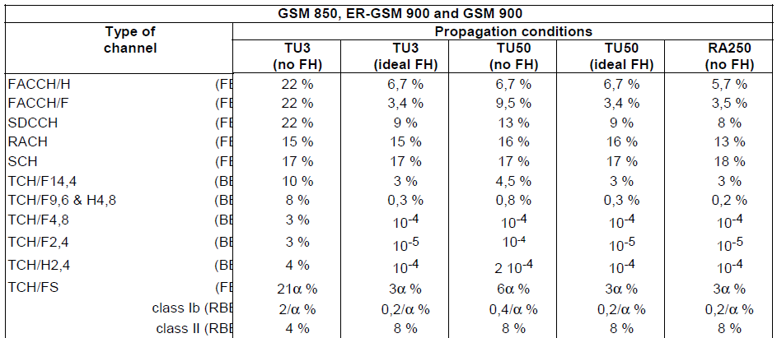

Figure 16: Specified performance level of GSM receivers

As one can see, for a full rate transport channel (TCH/FS), the Class II Residual Bit Error Rate (RBER), which is the BER after error correction, is 8% for all channel models, except in TU3 without FH (urban journey at 3 km/h) where it is 4%. This performance is rather poor and corresponds to a barely intelligible voice communication. As an illustration, the table below is an extract of GSM TS 05.08 [15] which shows the mapping between BER and voice quality in GSM downlink. From this table, we can deduce that a maximum of about 3% BER is necessary to provide an acceptable voice quality.

Table 23: BER to Voice Quality mapping in GSM downlink

| RxQual | BER | Voice Quality |
| --- | --- | --- |
| 0 | BER < 0.2% | Very good |
| 1 | 0.2% < BER < 0.4% | Good |
| 2 | 0.4% < BER < 0.8% |
| 3 | 0.8% < BER < 1.6% | Quite good |
| 4 | 1.6% < BER < 3.2% |
| 5 | 3.2% < BER < 6.4% | Poor |
| 6 | 6.4% < BER < 12.8% |
| 7 | 12.8% < BER | Very poor |

Since GSM-R provides railway emergency calls, it cannot be operated with the performance level specified in Figure 16. Therefore, a protection criterion of C/(N+I) = 9 dB is not sufficient to meet the requirements associated with GSM-R.

Indeed, some sources in the literature indicate that a C/(N+I) = 12 dB needs to be considered as a design target:

* ECC Report 229 Table 4 [15];
* “Considerations regarding a radio planning procedure for the GSM-R network covering the Bucuresti-Constanta railway corridor” [18];
* “GSM-R Radio Planning Guidelines” [19].

Therefore, it is believed that C/(N+I) = 12 dB ensures good operation of GSM-R cab-radios, and this value will be retained in the following sections of this contribution when deriving the protection criterion for GSM-R cab-radio.

* + 1. Minimum guaranteed wanted signal level

State-of-the-art cab-radio receivers have a typical noise figure of 5 dB (data from cab-radio manufacturer), and therefore the noise floor is -116 dBm/200 kHz (the same as in GSM-R BS receivers, see section A2.2).

Considering a necessary 12 dB C/(N+I), alongside with a 3 dB interference degradation margin[13], the minimum signal wanted signal level at the cab-radio antenna connector is -116 dBm + 12 dB + 3 dB = -101 dBm.

* + 1. Intra-system interference

Like every mobile network, GSM-R must accept a certain level of intra-system interference coming from adjacent cells. ECC Report 229 Table 4 [18] indicates that the intra-system interference is 20 dB on average below the wanted signal.

* + 1. Maximum acceptable external interference level

The minimum wanted signal level of $-101dBm/200 kHz$ (see section A2.3.2) must be $12 dB$ above the total noise and interference[14] power, which is thus $-113 dBm/200 kHz$. The thermal noise power is $-116 dBm/200 kHz$ (see section A2.3.2). The internal interference level is $20 dB$ below the wanted signal level, and therefore amounts to [15]. From this, we can deduce that the maximum level of external interference at the GSM-R cab-radio receiver is:

$$10×\log_{10}\left({10}^{-{113 dBm}/{10}}-{10}^{-{116 dBm}/{10}}-{10}^{-{121 dBm}/{10}}\right)= -117.7 dBm/200 kHz$$

This maximum level of $-117.7dBm/200 kHz$ corresponds to a maximum desensitization of 2.2 dB acceptable at the GSM-R cab-radio antenna connector.

* 1. Protection of FRMCS cab-radio

The same methodology as described in the previsous sections can be applied to LTE/NR cab-radios.

Inter-cell interference (ICI) is an important limiting factor in LTE/NR networks or, more generally, in all technologies reusing the same frequencies within a limited geographical area. There are several measures that can be taken to reduce it, and a complete listing of all possibilities that could be used in FRMCS is beyond the scope of this report. The frequency reuse scheme assumed in this coexistence study is shown in the figure below. It is a very basic version of the so-called *Fractional Frequency Reuse* (FFR). It consists in configuring FRMCS BS in such a way that the antenna pointing towards the left can only use the first 25 RBs (numbered #1 to #25), and the antenna pointing towards the right, the 25 remaining RBs (numbered #26 to #50). In this way, ICI is limited to a single adjacent cell as shown below (for the sake of simplicity, radiations at the rear of antennas are not considered).

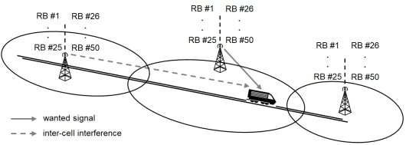

Figure 17: Assumed fractional frequency reuse scheme and inter-cell interference

As for GSM-R, it is likely that FRMCS requires a higher C/(N+I) than the one considered by 3GPP for MFCN. An increase of 5.6 dB is assumed here[16], taking into account the fractional frequency reuse.

The ratio between the wanted signal and the intra-system needs to be reassessed. According to RT(19)073016 (Figure 9) and to draft ECC Report 314[17] on coexistence between FRMCS in 1900-1910 MHz and other applications in adjacent bands (Figure 12), the *C/Iintra* to be considered is 14 dB taking into account the fractional frequency reuse.

This gives the following results:

* For a 1.4 MHz LTE carrier, the maximum level of external interference at the FRMCS cab-radio receiver is -112.2 dBm/MHz, corresponding to a maximum desensitization of 1.7 dB acceptable at the FRMCS cab-radio antenna connector;
* For a 5 MHz LTE carrier, the maximum level of external interference at the FRMCS cab-radio receiver is -111.3 dBm/MHz, corresponding to a maximum desensitization of 2.0 dB acceptable at the FRMCS cab-radio antenna connector.

Hence a protection criterion of -112.2 dBm/MHz (i.e. desensitization of 1.7 dB) is considered for the FRMCS cab-radio.

1. SRD technical parameters
   1. SRD in data networks
      1. EU Commission Decision

Table 24: 500 mW devices

|  |  |  |
| --- | --- | --- |
| Parameter | Value | Technology |
| Frequency bands | 874-874.4 MHz[18] | all |
| 916.1-916.5 MHz[19]  917.3-917.7 MHz  918.5-918.9 MHz | all |
| Maximum power | 500 mW e.r.p.  APC required (20 dB range) | all |
| Duty cycle | ≤ 10% for fixed NAP  ≤ 2.5% otherwise | al |
| Bandwidth | ≤ 200 kHz | all |

Table 25: 25 mW devices

|  |  |
| --- | --- |
| Parameter | Value |
| Frequency band | 917.4-919.4 MHz |
| Maximum power | 25 mW e.r.p. |
| Duty cycle | ≤ 1% |
| Bandwidth | ≤ 600 kHz  Typical: 200 kHz and 600 kHz |

* + 1. Indoor/outdoor deployment ratio for TN of data networks SRD

Table 26: Assumption about the indoor/outdoor ratio of TN

|  |  |  |
| --- | --- | --- |
|  | Indoor | Outdoor |
| Scenario1 | 30% | 70% |
| Scenario2 | 50% | 50% |
| Scenario3 | 70% | 30% |

* + 1. NBN (mesh networks)

Table 27: NBN characteristicse

|  |  |  |  |
| --- | --- | --- | --- |
| Parameter | NAP | NN (relay) | TN (terminal) |
| Bandwidth | 200 kHz | | |
| Antenna height | 7 m | 5 m | 1.5 m |
| Antenna pattern | Omnidirectional | | |
| Maximum e.i.r.p. | 29 dBm | | |
| OOB emissions | cf. ETSI EN 303 204 & ETSI TR 102 886 | | |
| Maximum duty cycle | 10 % | 2.5 % | 0.1 % |
| Average duty cycle | 2.5 % | 0.7 % | 0.05 % |
| Maximum density | 10/km² | 90/km² | 1900/km² |
| Average density | 5/km² | 45/km² | 950/km² |
| Outdoor/Indoor (%) | 100/0 | 100/0 | See Table 26 |

Regulatory Duty Cycle parameters are based on transmissions in any continuous one hour time interval. An NBN NN with a very much lower long-term average duty cycle may occasionally operate at up to 2.5% DC when measured over a given one hour interval. Assuming that all the devices (NAP, NN or TN) within a given square kilometre will be emitting at max DC during the whole day is extremely pessimistic and even unrealistic.

* + 1. CSS (spread spectrum one-hop networks)

Table 28: CSS characteristics

|  |  |  |
| --- | --- | --- |
| Parameter | NAP | TN |
| Bandwidth | 125 kHz ** | |
| Antenna height | 25 m (outdoor)  1.5 m (indoor) | 1.5 m (indoor/ outdoor) |
| Antenna pattern | omnidirectional | |
| Maximum e.i.r.p. | 29 dBm | 16 dBm |
| OOB emissions | cf. ETSI TR 103 526 | |
| Maximum duty cycle | 10 % | 1 % |
| Typical duty cycle | 0.5 % | 0.007 % |
| Maximum density | 3.5/km² | 3000/km² |
| Typical density | 0.5/km² | 360/km² |
| Outdoor/Indoor (%) | 100 % / 0 % | See Table 26 |

Regulatory Duty Cycle parameters are based on transmissions in any continuous one hour time interval. A CSS TN with a very much lower long-term average duty cycle may occasionally operate at up to 1% DC when measured over a given one hour interval. Assuming that all the devices (NAP or TN) within a given square kilometre will be emitting at max DC during the whole day is extremely pessimistic and even unrealistic.

* It should be noted that in the proposed approach, NAP deployed with 16 dBm e.i.r.p or lower are proposed to be modelled as TN.

** One or two 250 kHz channels are also anticipated operated with an e.i.r.p of 16 dBm (NAP and TN).

* + 1. UNB (ultra-narrowband one-hop networks)

Table 29: UNB characteristics

|  |  |  |  |
| --- | --- | --- | --- |
| Parameter | NAP Sc #1 | NAP Sc #2 | TN |
| Bandwidth | 1 kHz | 1 kHz | 250 Hz |
| Antenna height | 25 m | 7m | 1.5 m |
| Antenna pattern | Omnidirectional | | |
| Maximum e.i.r.p. | 29 dBm | 29 dBm | 16 dBm |
| OOB emissions | cf. ETSI TR 103 435 | | |
| Maximum duty cycle | 10 % | 10 % | 1 % |
| Typical duty cycle | 0.7 % | 3 % | 0.06 % |
| Maximum density | 0.1/km² | 0.1/km² | 2000/km² |
| Typical density | 0.01/km² | 0.01/km² | 343/km² |
| Outdoor/Indoor (%) | 100 % / 0 % | 100 % / 0 % | See Table 26 |

Note 1: Regulatory Duty Cycle parameters are based on transmissions in any continuous one hour time interval. A UNB TN with a very much lower long-term average duty cycle may occasionally operate at up to 1% DC when measured over a given one hour interval. Assuming that all the devices (NAP or TN) within a given square kilometre will be emitting at max DC during the whole day is extremely pessimistic and even unrealistic.

In the table above the regulatory values for Max DC are indicated, along with Typical DC values reflecting long-term average behaviour.

[Note 2: During the discussions at SE-24, it was revealed that the UL emission mask provided in ETSI TR 103 435 has shown to be inaccurate and is currently being reviewed by ERM TG28 as a matter of urgency.]

* 1. RFID

The technical characteristics of RFID are shown in the tables below. The information contained in the tables is consistent with ECC Report 200 and ETSI EN 302 208 v3.1.1 (2016-11)[22], except where noted.

Table 30: RFID characteristics

|  |  |  |  |
| --- | --- | --- | --- |
| Parameters | Interrogator - Fixed | Interrogator - Handheld | Tag |
| Frequency range | 916.1-916.5 MHz  917.3-917.7 MHz  918.5-918.9 MHz | 916.1-916.5 MHz  917.3-917.7 MHz  918.5-918.9 MHz | 915.5-919.5 MHz |
| Transmitter Power, dBm | 30.2 dBm | 27.0 dBm |  |
| Bandwidth | 400 kHz | 400 kHz | 1600 kHz (Note 1) |
| Tx antenna gain, dBi | 8.0 | 2.2 |  |
| Tx radiated power (e.r.p.), dBm | 36 dBm (Note 2) | 27 dBm (Note 2) | -10 dBm |
| Maximum e.i.r.p., dBm | 38.2 | 29.2 | -7.8 |
| Antenna height | TBD | TBD | TBD |
| Antenna pattern | (Note 3) | (Note 3) |  |
| OOB emissions | cf. Figure 6  in ETSI EN 302 208 [22] | cf. Figure 6  in ETSI EN 302 208 | cf. Figure 9  in ETSI EN 302 208 |
| Note 1: The tag backscatter is contained in two sidebands 320 kHz wide at fc ±640 kHz.  Note 2: Since RFID is primarily an indoor application using passive tags which is equivalent to a semi-shielded environment, an average of 20 dBm e.r.p. is suggested for compatibility studies (see Annex 2.5 in ECC Report 200 or Annex C of ETSI TR 103 151.  Note 3: See Annex 2.5 in ECC Report 200 for typical antenna patterns for fixed (e.g. hotspot, industrial, etc) and handheld (e.g. retail store) applications. | | | |

Five scenarios are considered:

* “Hotspot”: multiple RFID interrogators in a hotspot such as a large warehouse/distribution centre (dense interrogator scenario);
* “Airport”: RFID readers on conveyors at airport terminals for baggage handling (e.g. a baggage handling hall in an airport terminal building. Such systems would be carefully designed and have to satisfy the requirements of the airport frequency management department);
* “Store”: a line of interrogators at the check-outs of a store (a row of check-out counters at a supermarket; due to shorter distances only 500 mW e.r.p. is assumed);
* “Other”: a typical concentration of RFID interrogators in an outdoor environment (any other usage not specially defined);
* “Item tagging”: RFID in a store, i.e. an additional variation of the store scenario, in which individual items are tagged so that they may be identified.

Table 31: Parameters used for RFID as interferer

|  |  |  |  |  |  |
| --- | --- | --- | --- | --- | --- |
| Parameters | RFID Use Scenarios | | | | |
| **Hotspot** | **Airport** | **Store/item  tagging** | **Industrial** | **Other  (Note 1)** |
| ERP (dBm) | 36 | 36 | 27 | 24 | 36 |
| Antenna Gain (dBi) | 8 | 8 | 2 | 8 | 8 |
| Building Penetration Loss (Note 2) (dB) | 16 | 16 | 7 | 16 | (Note 1) |
| Density (per hotspot or per sq-km, Note 3) | 480 | 480 | 20 | 400 | 12 |
| DC, per channel (%) | 2.5 | 2 | 12.5 | 50 | 1 |
| Environment | Indoor | Indoor | Indoor | Indoor | Outdoor |
| Note 1: The most common “Other” RFID use scenario is RFID used for Automatic Vehicular Identification (AVI). For road tolling applications the antenna read zone is confined to a vehicle lane, and for parking lot and vehicular access applications the read zone is confined by using low transmit power. Therefore, 20 dBm is suggested for ERP in compatibility studies (combined transmit power and directional attenuation).  Note 2: The building penetration loss has been measured for indoor use scenarios and is shown in the table such that transmit power, antenna gain, and building loss result in an average of 20 dBm e.r.p. (see Annex 2.5 in ECC Report 200 or Annex C of ETSI TR 103 151).  Note 3: The values in the table are taken directly from Annex 2.5 in ECC Report 200. Since the time of publication, the number of Hotspot and Airport scenarios has been limited due to several factors. While there may be some cases where the high densities may be observed, they are rare and limited to a small geographic area. To some extent the same case is also true for Industrial scenarios. The most common RFID use scenario found today is retail store/item tagging. For this scenario the values in the table may apply is the typical sense, however, for retail “hotpot” areas like shopping malls, the density of RFID interrogators can be greater than the amount shown in the table. | | | | | |

* 1. Wideband data transmission in data networks

Table 32: WBN characteristics

|  |  |
| --- | --- |
| Parameter | Value |
| Frequency band | 917.4-919.4 MHz |
| Maximum power | 25 mW e.r.p. |
| Duty cycle | ≤ 10% for fixed NAP  ≤ 2.8% otherwise  polite spectrum access |
| Bandwidth | > 600 kHz  ≤ 1 MHz |

1. Examples of loss observed between MFCN and GSM-R in the 900 MHz frequency range
   1. Context of measurements

In the context of GSM-R interference mitigation procedures, measurements of MFCN BS’s levels are performed by the railway operator (SNCF Réseau).

MFCN operators provide e.i.r.p. values (CPICH and BCCH respectively for 3G and 2G networks) of neighbouring sites.

Based on this information, losses (including TX antenna discrimination) have been derived.

The measurements are provided in Section 2, and the methodology includes the following:

* Measurement from MFCN sites that do and do not interfere are both reported. Hence the range of loss reported includes losses from both neighbouring and remote sites. It should be noted that only the minimum loss has been retained in the results.
* Measurements are not exhaustive as only a limited number (7) of interference cases have been assessed. These cases have been selected randomly amongst all interference cases targeted by the mitigation procedure at the time of writing this contribution. It is therefore expected that lower values could exist.
* MCL could be even lower in locations where no interference has been reported yet.
* From the contributors’ point of view, the minimum observed value is relevant to derive minimum immunity performance.
* The measurements are performed in the 900 MHz band.
* The loss values have been derived with the following formula:
* **Loss (dB) = MFCN BS e.i.r.p. (dBm) – measured value (dBm)**
* The loss values include TX antenna pattern discrimination (for MFCN).
* The antenna gain and losses for RX are compensated (RX gain = 0 dBi).

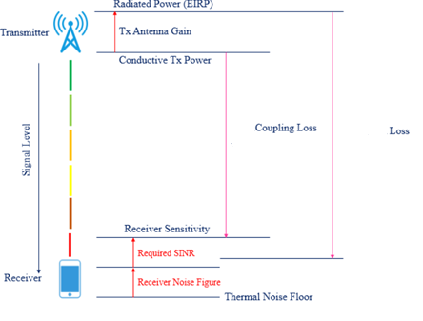

Figure 18: Assumed fractional frequency reuse scheme and inter-cell interference

**Remark:** No measurement exists for 1900 MHz, extrapolations could be done by taking into consideration additional propagation losses and specific antenna MFCN system (discrimination) for 1.9 GHz.

Contributors suggest SE-7 to derive expected interference signals and levels from MFCN BS at the receiving cab-radio, using the upper bound of the minimum loss value observed.

SE-7 is invited to specify maximum performance degradation of FRCMS cab-radios against interferences from MFCN BS in 900 MHz band (and possibly in 1900 MHz), in order to avoid mitigation procedure such as existing ad hoc GSM-R procedure.

* 1. Measurement results

Table 33: Measurements results

|  |  |  |  |  |
| --- | --- | --- | --- | --- |
|  | ***Minimum loss (dB)*** | | ***Number of samples*** | |
| **Case Name** | **2G** | **3G** | **2G** | **3G** | **Min GSM-R level** | **Max MFCN level 2G** | **Max MFCN level 3G (CPICH Pilot), see Note 1** |
| Conflans | 71.88 dB | 68.80 dB | 108 | 54 | -58 dBm | -15 dBm | -23 dBm |
| Jardin d'Eole | 75.80 dB | 72.70 dB | 138 | 68 | -64 dBm | -23 dBm | -26 dBm |
| Blanc Mesnil | 77.84 dB | 77.90 dB | 36 | 28 | -70 dBm | -21 dBm | -24 dBm |
| Courbevoie | 71.09 dB | 69.50 dB | 228 | 184 | -75 dBm | -13 dBm | -22 dBm |
| La Villette | 72.78 dB | 73.56 dB | 150 | 136 | -65 dBm | -17 dBm | -25 dBm |
| Nantes | 77.68 dB | 77.70 dB | 252 | 225 | -63 dBm | -16 dBm | -27 dBm |
| Strasbourg | 75.59 dB | 75.30 dB | 60 | 33 | -69 dBm | -19 dBm | -26 dBm |
| Note 1: It should be pointed out that 3G Pilot power is usually between 5 % and 15 % of the total Node B transmit power. Commonly, the CPICH power is 10 % of the typical total transmit power by a 3G BS. Based on this assumption, the measured power level of -22 dBm for a 3G pilot power corresponds to up to -12 dBm power level of total 3G BS power when both pilot and traffic channels are considered. | | | | | | | |

**Table 34: Average, median and standard deviation of the minimum loss values**

|  |  |
| --- | --- |
| Average value (*) | 74.17 dB |
| Median value (*) | 74.43 dB |
| standard deviation (*) | 3.13 dB |
| (*) based on the minimum losses presented above | |

The maximum level received from MFCN (at the connector of the GSM-R antenna) over the 7 cases considered is -13 dBm for 2G and -22 dBm for 3G (Pilot measurements). It is worth noting that about one fourth of the 2G transmitters of a MFCN network have higher e.i.r.p.se than the e.i.r.p. of the measured transmitter, hence this case is not the worst case.

e.i.r.p. of future 900 MHz networks, based on e.g. 4G or 5G technologies is out of the scope of this contribution.

* 1. Summary

The minimum loss observed at the worst measurement location is around 69 dB at 900 MHz band between MFCN BS e.i.r.p. and antenna cab-radio including the discrimination from TX antenna patterns.

1. List of references
2. Directive 2014/53/EU on the harmonisation of the laws of the Member States relating to the making available on the market of radio equipment
3. Decision EU 2018/1538: Commission Implementing Decision on the harmonisation of radio spectrum for use by short-range devices within the 874-876 and 915-921 MHz frequency bands
4. ERC Recommendation 70-03 relating to the use of Short Range Devices
5. Report ITU-R M.2039-3: Characteristics of terrestrial IMT-2000 systems for frequency sharing/interference analyses
6. Report ITU-R M.2292-0: Characteristics of terrestrial IMT-Advanced systems for frequency sharing/interference analyses
7. UIC O-8736: Assessment report on GSM-R current and future radio environment
8. ETSI TS 102 933-1: GSM-R improved receiver parameters; Part 1: Requirements for radio reception
9. ETSI TS 136 101: E-UTRA; User Equipment (UE) radio transmission and reception
10. ETSI TS 138 101-1: NR; User Equipment (UE) radio transmission and reception; Frequency Range 1
11. ETSI TS 101 601: ERM; The specification and implementation of design changes to interrogators and specification of the test plan for the Preliminary Tests and the Trial; Modification of interrogators and specification of test plans for the Preliminary Tests and Trial
12. GSM TS 05.05: GSM/EDGE; Radio transmission and reception
13. GSM TS 05.08: GSM/EDGE; Radio subsystem link control
14. GSM TR 03.30: GSM/EDGE Radio network planning aspects
15. GSM TR 05.50: GSM/EDGE Background for Radio Frequency (RF) requirements
16. ECC Report 200: Coexistence studies for proposed SRD and RFID applications in the frequency band 870-876 MHz and 915-921 MHz
17. ECC Report 229: Guidance for improving coexistence between GSM-R and MFCN in the 900 MHz band; 2015
18. Draft ECC Report 309[20]: Use of MFCN for the command & control and payload links of UAs within the current MFCN harmonised regulatory framework
19. C. M. Alexandrescu, L.-M. Nemtoi; Considerations regarding a radio planning procedure for the GSM-R network covering the Bucuresti – Constanta railway corridor; Scientific Bulletin of University Politehnica of Bucharest, Series C, Vol. 73, Issue 3, 2011
20. Jernbaneverket; GSM-R Radio Planning Guidelines; 2006
21. Reccommendation ITU-R F.1336-5
22. ETSI TS 136 104
23. ETSI EN 302 208
24. ETSI TS 145 005
25. ERC Recommendation 70-03

1. https://eur-lex.europa.eu/legal-content/EN/TXT/PDF/?uri=CELEX:32018D1538&from=EN
2. Germany, Switzerland and Liechtenstein
3. It may be as high as 6 dB in some circumstances.
4. “Decorrelation distance characterisation of long term fading of CW MIMO channels in urban multicell environment” Alayon Glazunov, Andres; Wang, Ying; Zetterberg, Per Published in: 18th International Conference on Applied Electromagnetics and Communications, 2005. ICECom 2005.
5. ECC Report 309 determines separation distance needed to protect RMR cab-radio from aerial UE. ECC Report is expected to be approved for public consultation at ECC Plenary meeting in March 2020.
6. -36.2 dBm for a desensitization of 1.7 dB is equivalent to -33 dBm for a desensitization of 3 dB.
7. 58 dBm e.i.r.p. = 46 dBm output power + 15 dBi antenna gain – 3 dB feeder loss (cf. Table 3 in Report ITU-R M.2292-0)
8. -13 dBm (cf. ETSI TS 102 933-1)
9. -29.3 dBm for a desensitization of 1.7 dB is equivalent to -26.1 dBm for a desensitization of 3 dB.
10. -49.6 dBm for a desensitization of 1.7 dB is equivalent to -46.4 dBm for a desensitization of 3 dB.
11. -30 dBm for a desensitization of 1 dB is equivalent to -24.2 dBm for a desensitization of 3 dB.
12. The thermal noise equals $-174dBm/Hz$, which leads to $-174\frac{dBm}{Hz}+10*\log_{10}\left(200 kHz\right)= -121 dBm$ thermal noise for a $200 kHz$ GSM-R channel bandwidth, to which must be added the $5 dB$ noise figure.
13. This margin allows the receiver to face a desensitization due to internal and external interference (see GSM TR 03.30 Annex A [16] and GSM TR 05.50 clause H.3.3 [17]).
14. This accounts for both internal and external interference.
15. -101 dBm – 20 dB, see Section A2.3.3.
16. A C/(N+I) of 4 dB has been measured during a PoC conducted at 1900 MHz: it corresponds to a minimum bit rate of 2 Mb/s DL, which is roughly the DL throughput targeted after the migration (see Table 6 in ECC Report 294). The C/(N+I) value used in 3GPP is -1.6 dB; meaning the C/(N+I) increase for railway usage is around 5.6 dB.

    According to 3GPP for band #39 (1900 MHz):

    * Occupied BW = 9 MHz
    * Noise figure = 9 dB (TR 36.942, Tables 4.6 and 4.8)
    * N = -95.4 dBm
    * Sens = -97.0 dBm
    * C/(N+I) = -1.6 dB

   
17. Will be in public consultation at the same time as this ECC Report
18. Harmonised frequency band as per Decision EU 2018/1538
19. Dependent upon the results of work item SE24_61
20. ECC Report 309 is expected to be approved for public consultation at ECC Plenary meeting in March 2020.